Alan Yu

Organic Lab 309:03

Santanu Malakar

Unknown Analysis

April 22, 2019

**Prep:**

IR was done using small amounts of compound on IR plates with the IR machines in the lab. NMR was done using an NMR tube with the three finger thickness rule with CDCl3 as the solvent.

**IR Analysis:**

Based on the IR, in the 1600 $cm{{}^{-1}}^{}$ to 1700 $cm{{}^{-1}}^{}$ region, there is a broad shift that resembled the stretch of a ketone that was part of an amide. In the 3500 $cm{{}^{-1}}^{}$ region the broad stretch there could be the amide ketone overtone or just water. In the 3300 $cm{{}^{-1}}^{}$ region there was also a stretch that could match the stretch of a secondary amine since there was only one peak instead of two distinct peaks in that region. For the 3000 $cm{{}^{-1}}^{}$ region, there was a stretch that resembled a sp3 Carbon. There was a lack of aromatic stretches within the IR. With the IR, the conclusions made were that there had to be a sp3 Carbon, a secondary amine, and an amide within the structure.

**H-NMR Analysis:**

Based on the H-NMR, there seems to be that each carbon that is connected with the Hydrogen, has to have no other Hydrogens branching off of it since each of the peaks are all singlets. The peak that has one Hydrogen at the 5.7 ppm level has to be on a double bond since the other possibility of being on amine group on the benzene is disproved by IR. The peak around 2 ppm which holds 4 Hydrogens could be the groups that are connected to nitrogens or just carbons with Hydrogens near a -NH group. For the 1.8 ppm area with around 3 Hydrogens, it could be a -CH3, -CH2, or -CH group. And the final peak with 8 Hydrogens around the .9 ppm region could be more hydrogens on a -CH3, -CH2, or -CH group.

**C-NMR Analysis:**

Based on the C-NMR, there seems to be no symmetry involved with the compound. For the 200 ppm it has to be a ketone group. For the 160 ppm it could either be an amide or part of an alkene. In the 125 ppm region, it most likely is an alkene carbon. There were peaks for the solvent in the NMR so that was removed from the consideration. In the 51 ppm area, it could be an amine or an alcohol. For the 45 ppm, it is most likely an amine group. For 33 ppm, the group could be a sp3 Carbon, the 28 ppm could be the carbon next to the ketone, and the last reading of 24 ppm could be a -CH2 group with two R groups attached to it.

**Discussions:**

After going with the NMR and IR data, the issue of getting the correct compound would be piecing the groups correcting considering that each of the peaks in the H-NMR were singlets. This makes it trickier since it doesn’t help as much than an H-NMR with splitting constants. This was harder to determine also partly because of poor IR and NMR spectra that was gathered and not being redone in time.

**References:**

The references that were used to see how the structures could be built were from the Aldrich Library of FT IR Spectra and the Aldrich Library of NMR Spectra (found at LSM). These were used to give a rough idea before building the unknown.

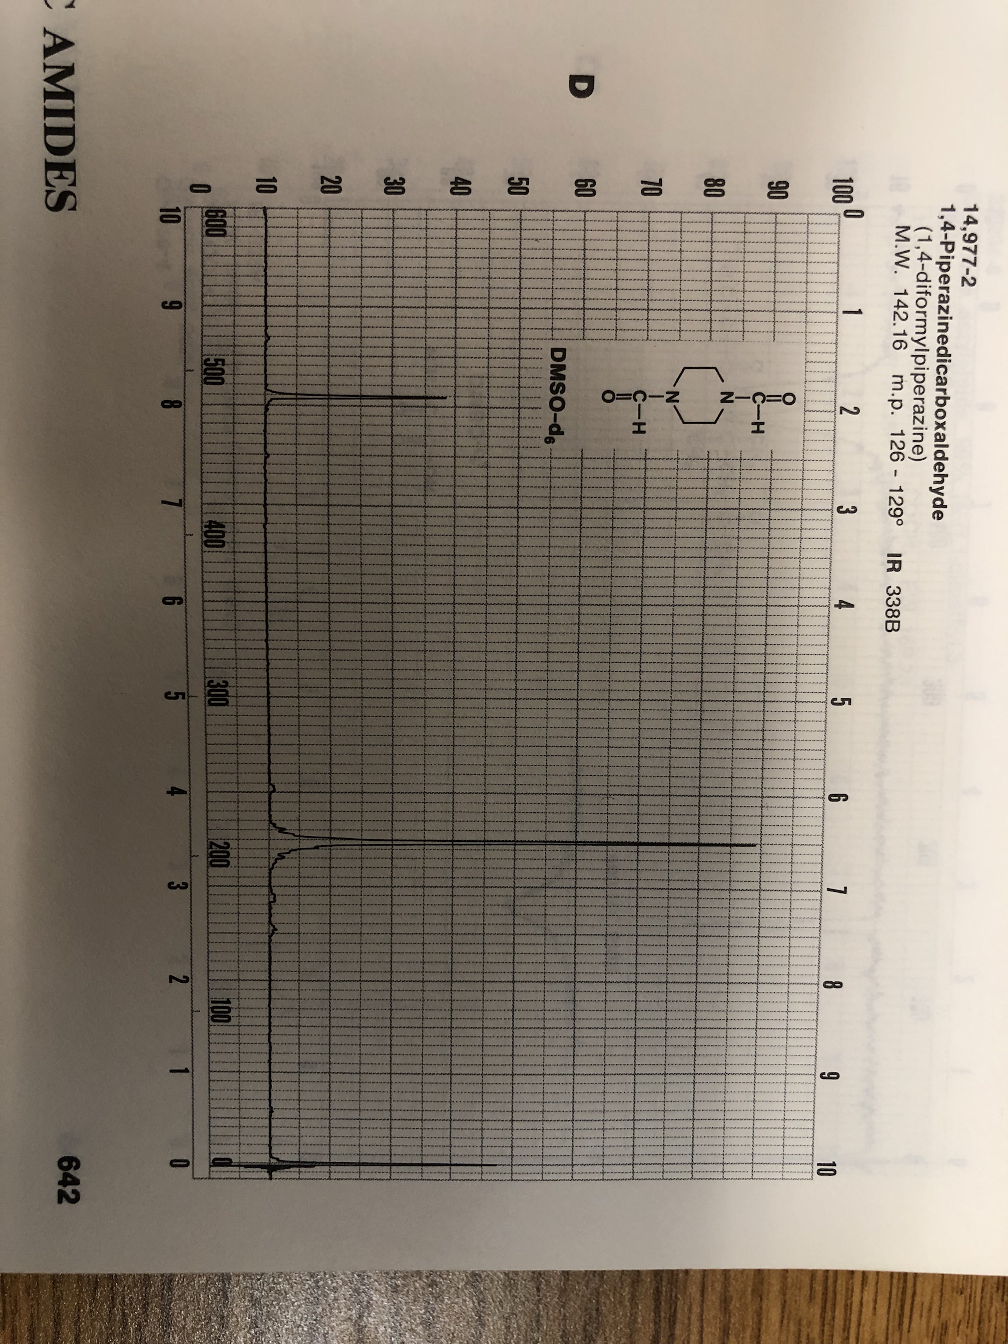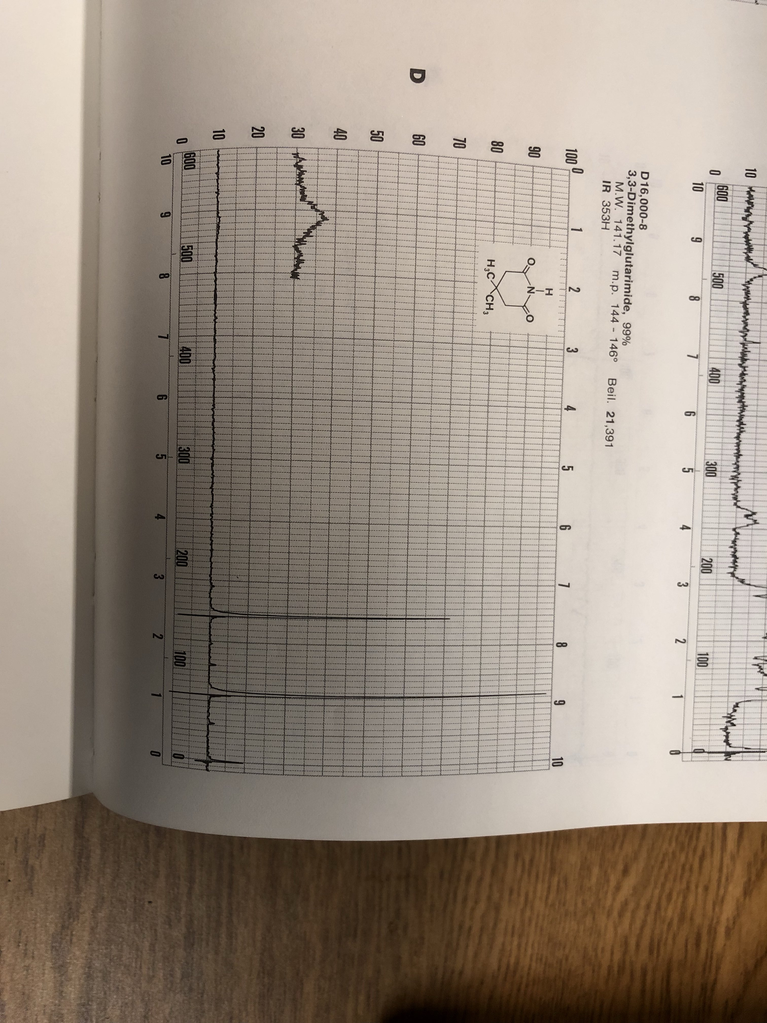

**Structure(s):**

This was the furthest that could be determined, but did not match the spectra at all.

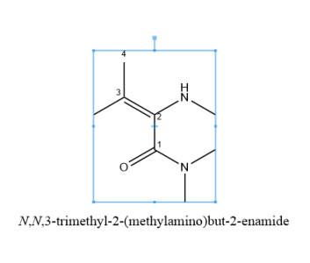

HNMR of this:

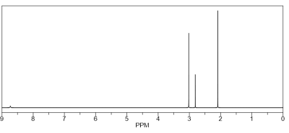

CNMR of this:

